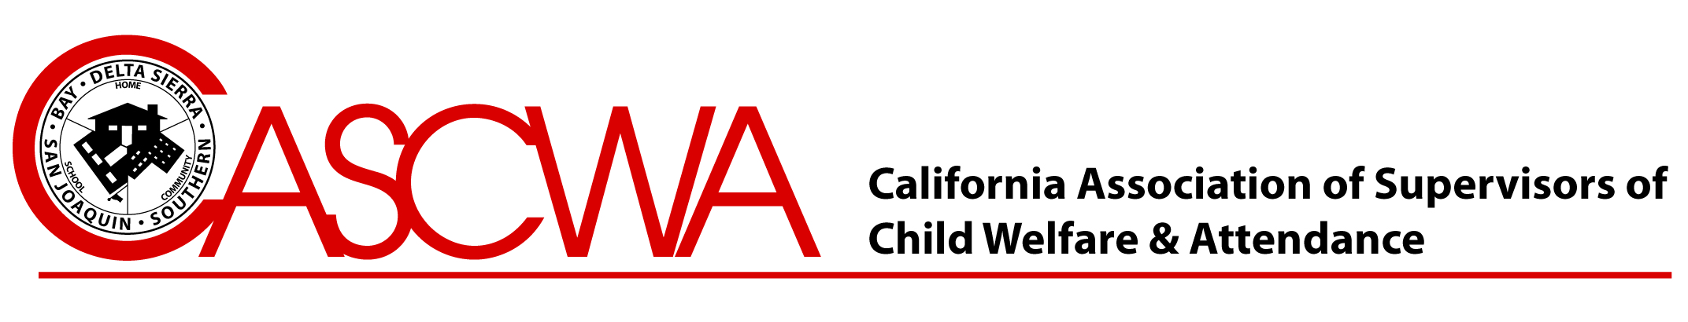
Richard C. Davis Scholarship Award
The California Association of Supervisors Child Welfare and Attendance, Delta/Sierra Section established the Richard C. Davis Scholarship Award in May 1986. Two, $1000 scholarships will be given out this year to a continuation or alternative school graduating senior who plans to continue his/her education in college or a vocational training school. This prestigious award was designed to recognize the resilience of students who overcome personal obstacles to graduate from high school and continue their education or pursue advance training to develop entry level skills leading to gainful employment.

A continuation or alternative school student is defined as eighteen (18) years old or younger, who returns to school and graduates from high school, continuation school, a regional occupational program (ROP), community school or juvenile court school.

Delta Sierra is proud to announce the offering of two re-occurring scholarship opportunity to previous Richard C. Davis Scholarship recipients. To re-apply for the Richard C. Davis Scholarship, students must still be attending college or a vocational training school to be considered.
CASCWA is an organization comprised of school and community professionals who are dedicated to improving school climate, safety, and increasing school attendance. We create a network of professional support, mentors and educators to influence relevant legislation and advocate for the needs of students, families, and schools.

Visit us at:
www.cascwa.org

Eligibility: To be considered for the scholarship, student must attend a continuation or alternative school in one of the Delta/Sierra Section’s regions: Alpine, Amador, Butte, Calaveras, Colusa, Del Norte, El Dorado, Glenn, Lassen, Modoc, Nevada, Placer, Plumas, Sacramento, Shasta, Sierra, Siskiyou, Sutter, Tehama, Trinity, Yolo or Yuba Counties.

Required Materials:

- Attached application form
- Letter of Recommendation from an attendance supervisor, principal, vice principal, counselor or teacher or proof of college registration
- Verification of student status towards graduation, acceptance to college or planned program for advance training
Must be received on or before April 2nd

Send to:

Richard C. Davis Scholarship
PO Box 565
Woodland, CA 95776

For additional information, please contact Lisa Sanchez 530.662.4331 or lisa.sanchez@wjusd.org

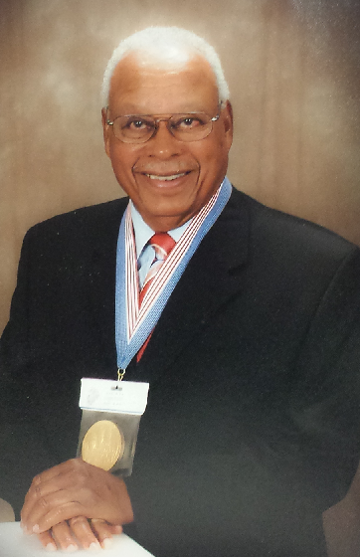
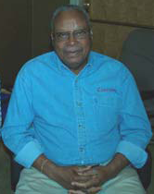
Who Is Richard C. Davis?

Richard retired in 1986 from the Sacramento County Office of Education as Child Welfare and Attendance Project Manager. He was born and raised in the Los Angeles area. After high school he enlisted in the United State Marine Corp during World War 2. After his tour of duty in the Asiatic Pacific Theater of Operation he returned to the states to become one of the famous Montford Point Marines.
Rich started his college career on the G.I. Bill and worked for the Los Angeles County Department of Parks and Recreation. He married and started his family. He persevered because he believed that in our society education was the pathway to a better future.
His professional career began in 1952 as a Teacher, School Community Liaison Officer, High School counselor and Supervisor of Attendance. He also served as coordinator of summer school, supervised home teachers, and continuation school counselor.
Richard C. Davis
Montford Point Marines
Congressional Gold Medal Recipient

Rich has been involved with the California Association of Supervisors Child Welfare and Attendance since 1969. He has been State President, Southern Section Vice President, Northern Section President and Delta Sierra President. After retirement, he continued on the state board and is a virtual life-time member.
Rich has given himself unselfishly for sixty plus years while working for school districts and county office of education. He used the system well for its diversity and capacity for evaluating results. He has been successful by substituting some realistic strategies and programs for competing ideologies. His experience and working with school age youth has led him to believe the foundation for every state is the education of its youth.
The Richard C. Davis perpetual scholarship was established by the Delta Sierra Section of the California Association of Supervisors Child Welfare and Attendance to recognize the contributions Rich Davis has made to the association and for the enduring services he has rendered to school age students.
“Through learning we re-create ourselves. Through learning we become able to do something we were never able to do.” -Peter Senge
Richard C. Davis Scholarship Award Application Form
(Please type or print)
Personal Information:
Name: Gender: Male Female Date of Birth: / /

Home Address: City: Zip:

Home Phone: Cell Phone:

Email Address:

Education:
School of Attendance: Date: Expected Graduation Date: _

School Address: City: _______ Zip: _

School Contact Name: Phone: Email: _ _ _

I plan on furthering/continuing my education by enrolling in/at: ________________
(Name of School or Institution)

Please describe what inspired you to return to school to continue your education: (300 words or less)
**please use the back page for further explanation if necessary**
Please describe what inspired you to return to school to continue your education (CONT): (300 words or less)

Completed scholarship packet must be received on or before April 1st
Packet Checklist: Return to: Richard C. Davis Scholarship
 Completed Application Form CASCWA - PO Box 565, Woodland, CA 95776
 Letter of Recommendation
 Verification of Student Status □ Returning applicant

We’re on the web:
www.cascwa.org

CASCWA includes four regional sections of California:

Bay Area , Delta-Sierra , San Joaquin Valley and Southern California.
A Scholarship Opportunity for YOU!

$1000

Richard C. Davis Scholarship Fund
Delta Sierra Section
PO Box 565
Woodland, CA 95776

